Eyeconic - Glasses Shop Management System

Use-Case Specification: Add Brands

Version 1.0

Revision History

|  |  |  |  |
| --- | --- | --- | --- |
| **Date** | **Version** | **Description** | **Author** |
| 07/11/2019 | 1.0 | Start creating use case | Đỗ Nguyễn Hoàng Ân |
|  |  |  |  |
|  |  |  |  |
|  |  |  |  |

Table of Contents

1. Add Brands 4

1.1 Brief Description 4

1.2 Basic Flow 4

2.2 Exception 4

2.2.1 Add brand 4

2.2.2 Fill in the brand information 5

2. Special Requirements 5

3. Preconditions 5

4. Postconditions 5

5. Extension Points 5

Use-Case Specification: Add Brands

# Add Brands

## Brief Description

This use case defines the step of adding existing Brands from the database.

Brands are added by the admin.

## Basic Flow

The system administration clicks the add button. The administrator fills in the information of the new Brands. The system displays the updated management parameter value and logs the change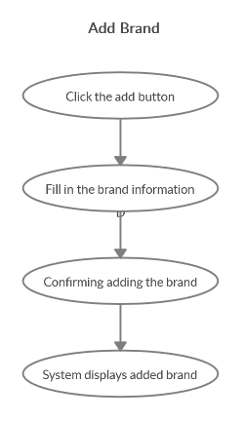

***Basic flow of Adding a Brand***

Step 1: Click the add buttons

The modal view shows up

Step 2: Fill in the brand information, name, type, …

Step 3: Confirming adding the brand by clicking the “Save” button.

Step 4: Successful added brand is added to the screen.

## 2.2 Exception

### 2.2.1 Add brand

The add button cannot be clicked or isn’t appeared on the screen

### 2.2.2 Fill in the brand information

Invalid information.

Must fill out all the information in the form.

2.2.3 Confirming adding the brand

The “Save” button is clicked but the new brand are not added to the database.

This new brand are existed in the database.

2.2.4 System displays added brand

The added brand is not display correctly

# Special Requirements

No Special Requirements

# Preconditions

User must already login as the administrator of the website.

# Postconditions

Admin can add glasses, lens, … to this brand

# Extension Points

Administrator check the website and the system to ensure that the new brand is added to the database and display on the screen.